

‘**Shoot Out’ Challenge**

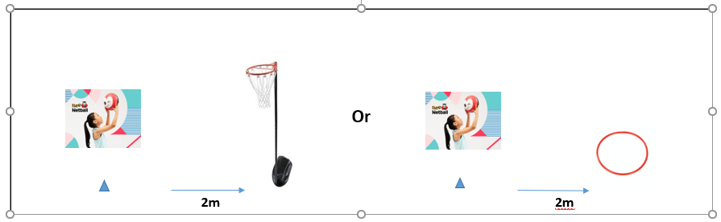

**Equipment**

1 size 4 netball

1 cone

1 post or hoop

1 stopwatch

**What to do:-**

* Mark a cone 2m away from the front of the netball post (post set at:- 9ft yrs 5/6, 8ft yrs 3/4)
* Players stand by the cone and shoot the ball into the net to score
* Count the number of successful shots in 30 secs
* Schools without posts. Place a hoop 2m away from the cone. Players shoot the ball upwards and the ball must land in the hoop when it hits the floor.



**Video Link**

<https://youtu.be/Yoa_jgTFaFc>