

**Long Pass Challenge**

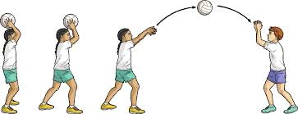

**5m**

**What to do:-**

* Mark 2 cones 5m apart
* Players pass the ball overhead between each other
* Count the number of passes in 30 secs
* Both players are credited with the total number of passes

**Video Link**

<https://youtu.be/Hi7ULT6P1hg>



**Equipment**

1 size 4 netball

2 cones

1 stopwatch