





**Rugby Challenge**

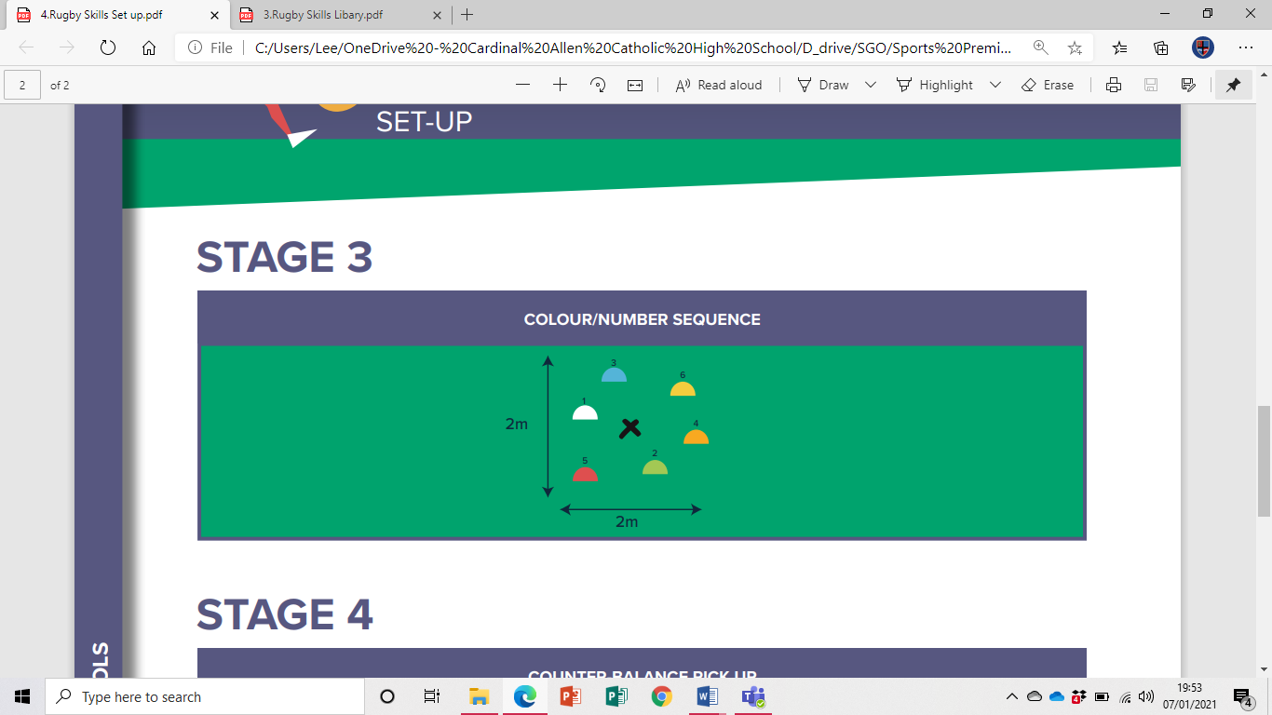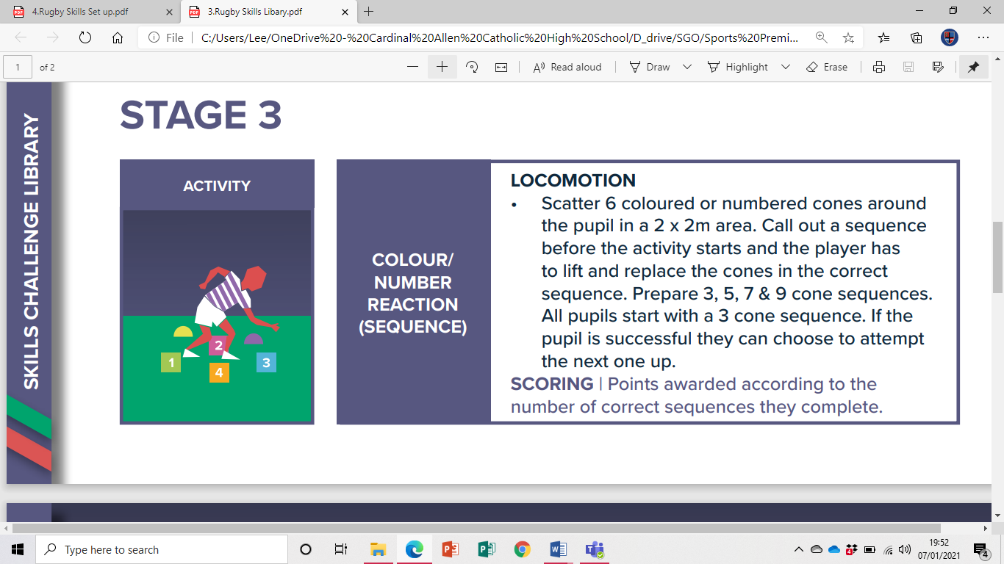**Colour/Number Sequence**

**Video Link**

<https://youtu.be/Ij4QYD_HMzk>

**Equipment**

6 Different coloured cones or numbers

1 Rugby ball (or any ball/object)