



**Video Link**

https://www.youtube.com/watch?v=pc4eQu5Pdt4&feature=youtu.be

**Fast Feet Challenge** 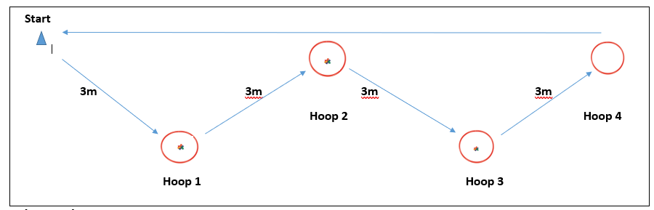

**What to do:-**

* Set the course up as above, placing 6 beanbags in each of hoops 1, 2 & 3.
* Player starts by the cone.
* They run the zig-zag to hoops 1, 2 & 3 collecting 1 beanbag from each as they go and place them in hoop 4. They run round hoop 4 and straight back to the start cone. This is repeated for 30 secs.
* At the end of the 30 secs the player scores a point for all the beanbags in hoop 4 and any they have in their hand.



**Equipment**

4 hoops

1 cone

18 beanbags

1 stopwatch