



**Rugby Challenge**

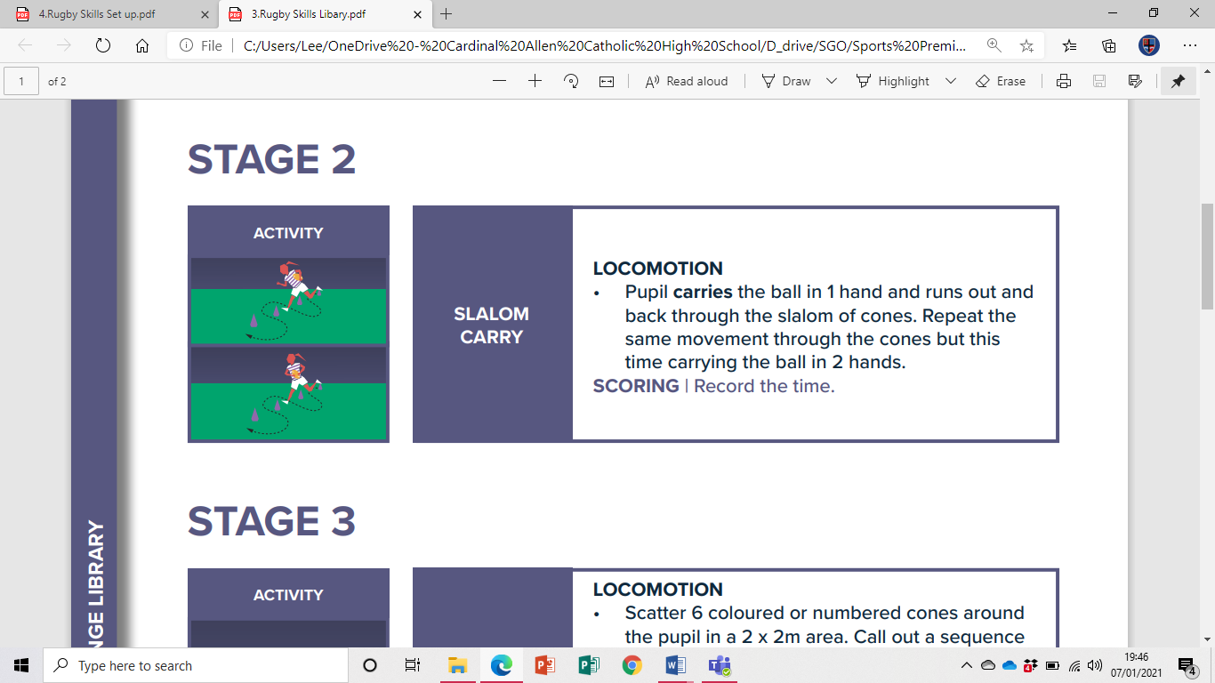**Slalom Carry**

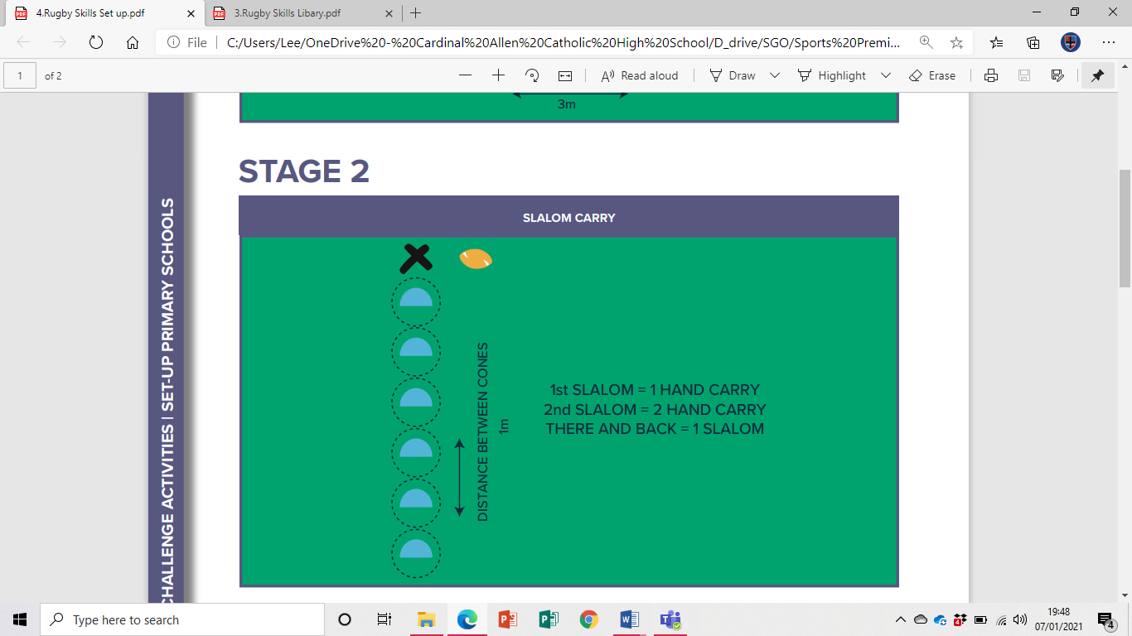

**Video Link**

<https://www.youtube.com/watch?v=wrwpyw9XNxg&list=PLDFsJr6kGBTO_SkJOgPYHry2P1zLQAFII&index=4>

**Equipment**

6 Cones

1 Rugby ball (or any ball/object)