

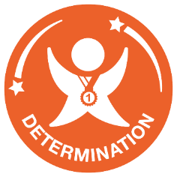

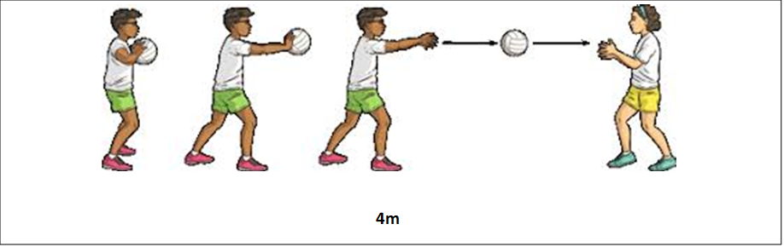 **Short Pass Challenge**

**Video Link**

https://www.youtube.com/watch?v=4O47OSqpS8k&list=PLDFsJr6kGBTO_SkJOgPYHry2P1zLQAFII&index=3

**What to do:-**

* Mark 2 cones 4m apart.
* Players chest pass the ball between each other.
* Count the number of passes in 30 secs.
* Both players are credited with the total number of passes.

**Equipment**

1 Size 4 Netball

Stopwatch

2 Cones

