





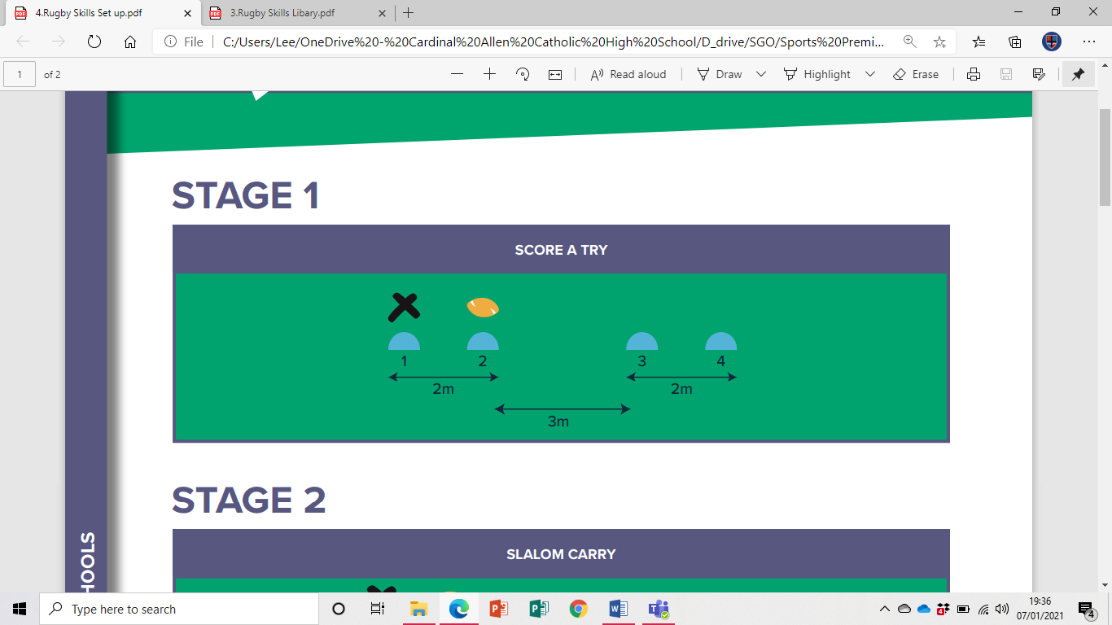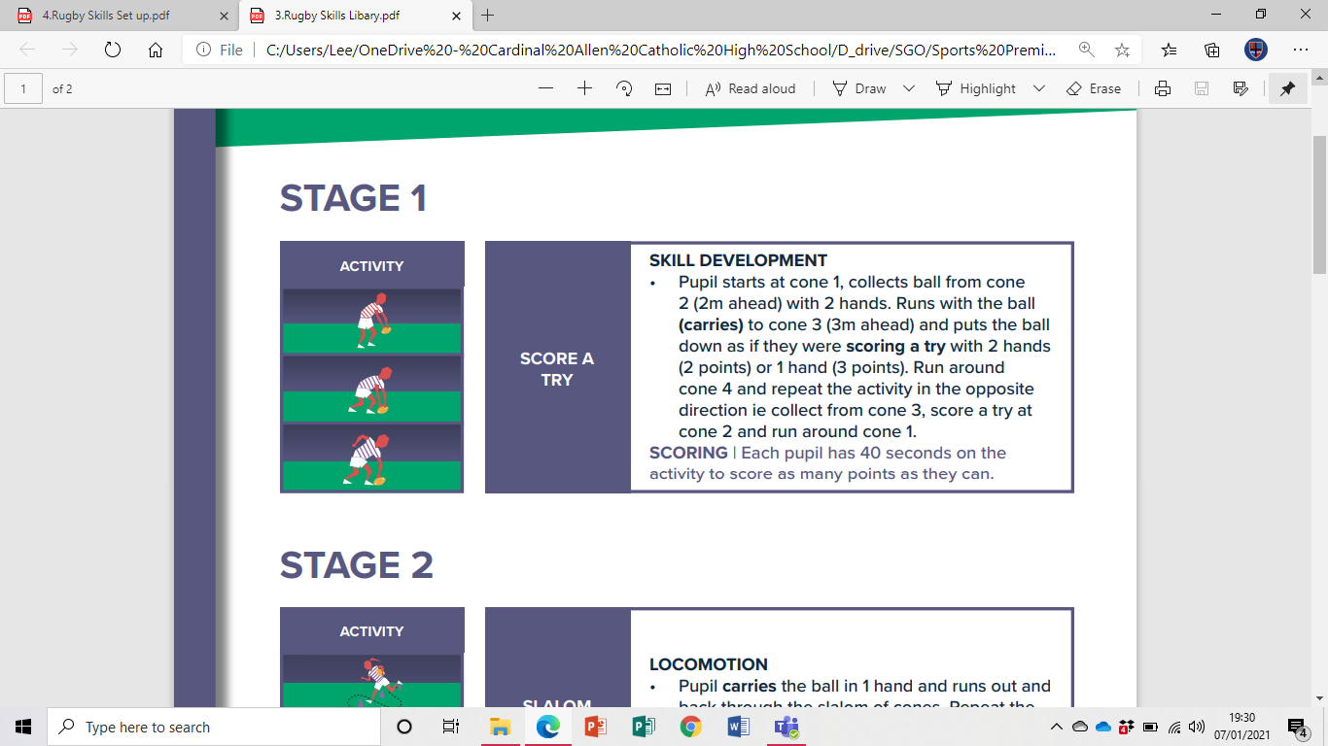**Rugby Challenge**

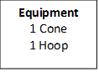**Score A Try**

Video Link

[(2) Rugby Week 1 - YouTube](https://www.youtube.com/watch?v=JP4u7347ySQ&list=PLDFsJr6kGBTO_SkJOgPYHry2P1zLQAFII)